
Year 11 ATAR Chemistry
Practical Assessment – Validation Test
Firework colours and Flame Tests

NAME: ________________________ TEACHER: ________________________
MARKS: _____ /32
Instructions:
- You have 35 minutes to complete this assessment.
- You will be provided with the ATAR Chemistry Data book.
- Please answer the questions in the space provided.
Questions:
- List the independent and dependent variables for this experiment. (2 marks)

- Identify three variables that needed to be controlled in this experiment. (3 marks)

- What colours were visible when the following ions were present in the flame? (4 marks)

Ion: | Colour exhibited:
Barium (Ba²⁺)
Calcium (Ca²⁺)
Potassium (K⁺)
Strontium (Sr²⁺)

- Explain why this experiment is called a ‘qualitative analysis’. (1 mark)

- Draw the electron structure and write the electron configuration for the following elements:

SODIUM | MAGNESIUM | CHLORINE
Electron structure: | Electron structure: | Electron structure:
Electron configuration: | Electron configuration: | Electron configuration:
(6 marks)

- What are the comparisons that can be made between this basic experiment and the Atomic Absorption Spectrometry analysis covered in class. (3 marks)

- Describe what occurs when an atom absorbs visible light and use a diagram to illustrate your answer.
(4 marks)

- Describe what occurs when an atom emits visible light and use a diagram to illustrate your answer.
(4 marks)

- The following diagram is a representation of the electromagnetic spectrum. Estimate the wavelength range of the light emitted by atoms of the listed elements. (5 marks)

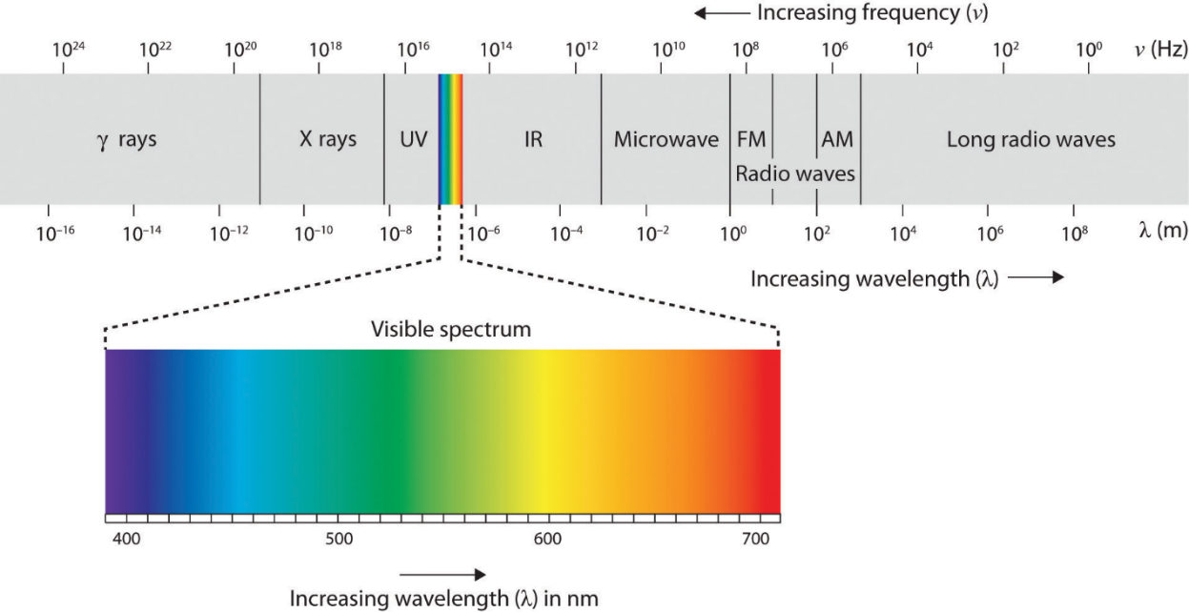

Element: | Approximate emitted wavelength range (nm)
Strontium
Calcium
Potassium
Sodium
Copper

End of Validation Test

